**­­­­­­PROJECT PHASE-1**

**MINI UPS INVERTER**

**Problem statement:**

Mini UPS Inverter: A small portable steady AC power supply using batteries with at least 3 plug points and capacity to run 1 to 2 hours.

**Objective:**

To design a UPS inverter to supply a uninterrupted power supply to the connected loads when there is a power outage.

To calculate the battery backup time for the circuit i.e connected with 3 laptops as a load.

**Solution:**

**Normal Mode Operation:**

From the main supply, Power will be provided to the 3 connected loads. AC input is converted into DC by rectifying process for storing it in the rechargeable battery. This DC is converted into AC by the process of inversion and given to the load or equipment which it is connected. The rectifier which is powered with the normal AC current is directly driving the inverter

**Battery Backup Operation:**

When the main supply is not available then the battery will provide power to the load. When there is any power failure, the rectifier have no role in the circuit and the steady power stored in the batteries which is connected to the inverter is given to the load by means of transfer switch. During a main power breakdown, this UPS system operates with zero transfer time.

**Block Diagram and its Working:**

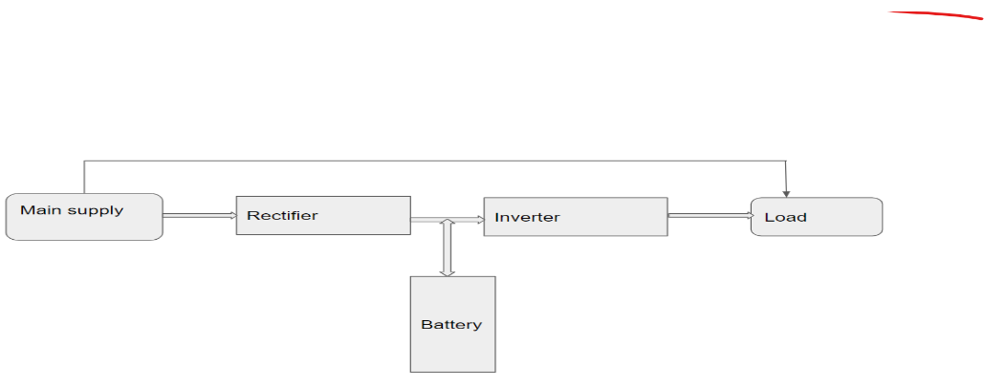

**Main supply** is to provide 230V(AC).The form of electric power that is delivered to the load.A voltage of 230V and frequency of 50 Hz is used as the combination.

**Rectifier** circuit is used to convert AC to DC.As the UPS has the battery inside it,and the battery can store only DC.

**Battery** is connected with the output of the rectifier.When the UPS is connected to the power supply the battery will charge.

**Inverter Circuit**,DC supply we need AC supply as output to drive the load.So,the inverter circuit is used to convert DC to AC.

**Circuit Diagram:**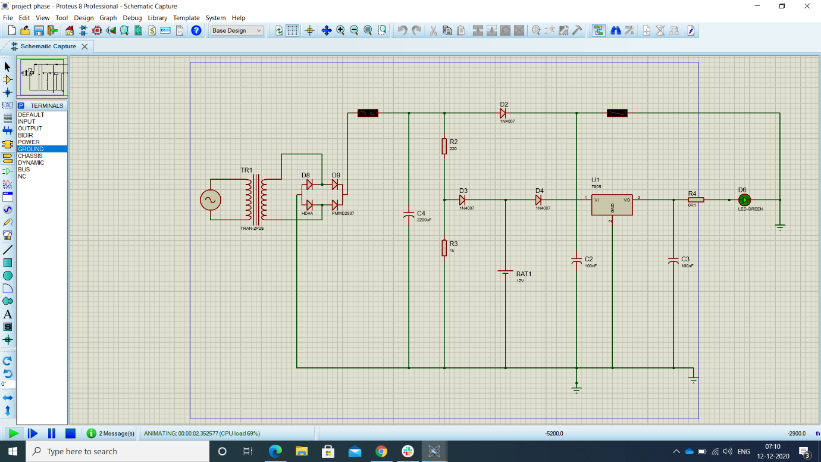

**Working:**

A 230V/12V step-down transformer is used. So first 230V AC supply steps down to 12V AC. Then a bridge rectifier using PN Junction diodes is used to convert 12V AC to 12V DC. After the bridge rectifier, a Fuse of 2A is used for protection purpose.

                 Then a Capacitor is connected in parallel for filtering the impure DC into pure DC. An LED is connected through the resistor for indicating purpose. Diode D1, D2, and D3 are connected in such a manner, that when the main supply is available the battery will be charged through diode D2. At the same time, the output supply will be available through the diode D1.

               When the main supply is not available then the battery will provide power to the load through the Diode D3. The Diode D2 will block the reverse power supply from the battery to the transformer. IC7805 is used to provide 5V DC regulated power supply at the output.

**Components Used:**

* Transformer-230V/12V,3A
* Bridge Rectifier
* Capacitor-2200 microfarad
* Capacitor-100 nanofarad
* Resistor-1K
* Diode-IN4007
* Voltage Regulator-IC7805
* LED-Green-3V

**Calculations:**

To calculate for battery backup time to withstand for a three loads connected with a laptop.

**1)If we use 12V,30Ah lithium ion battery means,the battery backup time will be 1hour 30 mins.**

Total Load = 3*64=192W

V=12V

P=VI

192=12*I

I=16A

Battery backup=30Ah/16A

=1.875 hours

For 80% efficiency,

0.8*1.875=1.5 hours

=1 hour 30 mins

It will take battery backup time as **1hr 30mins**

**2)If we use 10.8V,40,000mAh lithium ion battery means, the battery backup time will be 1hour.**

Total Load = 3*90=270W

V=10.7V

P=VI

270=10.8*I

I=25A

Battery backup=40Ah/25A

=1.6 hours

For 80% efficiency,

0.8*1.6=1.12 hours

=1 hour 7mins

It will take battery backup time as **1 hr 7 mins**

**3)If we use 3.7V,50,000mAh lithium ion battery means,the battery backup time will be 1hour**.

Total Load = 3*90=270W

V=3.7V

P=VI

270=3.7*I

I=72.9A

Battery backup=50Ah/72.9A

=0.685hours

For 80% efficiency,

0.8*0.685=0.54hours

=32minutes

It will take battery backup time as **32mins.**

**LINKEDIN CONTENT:**

"It always seems impossible until it

is done"-By Nelson Mandela

Done and evolved a lot, with the completion of the project phase-1 [**INNOVATORS**](https://www.linkedin.com/feed/) under the guidelines of [**NIKHIL SHRIRAM RAVICHANDREN**](https://www.linkedin.com/feed/) for our project-MINI UPS INVERTER.

We have designed a Mini ups inverter. Starting from doing reverse engineering on Powerbank and knowing about the small things in the design calculations and upto building the whole circuit connections.

Thank You [**INNOVATORS**](https://www.linkedin.com/feed/) for guiding me through out the project phase.

Working with a fantastic team [**Sahaya Reshma J**](https://www.linkedin.com/feed/) [**Niveda V**](https://www.linkedin.com/feed/) [**Abinaya S**](https://www.linkedin.com/feed/) made me understand the value of team spirit.

Special thanks to our tech mentor [**Harshapradha M**](https://www.linkedin.com/feed/) for guiding us throughout this project and [**SREE PAVITHRA**](https://www.linkedin.com/feed/) for mentoring us.

And hereby,I have attached my documented works of my 1st project. **#engineering** **#innovation** **#happylearning**